**CS 550 Final Project Report**

Haoxiang Wang

#932359049

# Abstract

In the final project, I created a solar system in a crystal ball, and I also added several other features into it. In this report, the final will be describe in the following sections: my proposal, my achievements, the differences between proposal and result, the highlights in my project, things I learned from this project, and the screenshots.

# 1. Proposal

In this final project, I am planning to implement a solar system in a crystal ball with several other features.

The main part of this project will be creating the solar system and make a shiny crystal ball. I’m planning to use lighting and texture mapping in creating the solar system. Creating the crystal ball is the mainly challenge for me in this project, since it is exactly new to me and we haven’t done anything similar in the class. I assume that shader will be used in creating the ball.

In the project, I am planning to set two kinds of views, one from outside of the crystal ball and one inside of the ball. When users are using the outside view, they should be able to use mouse to do the rotation and scaling just like any other project we did in the class. When users are using the inside view, they should be not only using mouse to do the rotation and the scaling but also using “WASD” on the keyboard to move the camera.

I am also planning to put two switches in the menu which control some environment changes in the crystal ball. One is for the snow, it controls whether there will be snow falling in the crystal ball. Another one is for several colored “disco lights”, it will control several colored spotlight staring from the bottom of the crystal ball and moving the directions around. There will be another switch which will turn on a “space trip”, the camera will start from earth and go around to visit every planet in the system and finally go back to the earth.

The features I am planning to do in the final project are all listed and described above. To implement them I need to use almost everything I learned in the class and I also should learn some new techniques at the same time. Hope these will result in a good final project for this class.

# 2. Achievements

I have completed almost everything I mentioned in the proposal. I made a solar system and put it into a translucent ball with a wood stage.

I set two kinds of views to it. The outside view is the view that viewer is outside of the crystal ball, and the inside view is the view that viewer is inside the ball. In the inside view, the full of stars space will show and let the viewer get the sense of true space. When viewer is using inside view, he or she is able to use “WASD” keys on the keyboard to control the move. The outside and the inside views are shown in the figure 1 and 2.

I also create several switches to handle the environment. I set one “DISCO!” switch to turn the disco mode on and off. When the disco mode is on, the original lighting will be replaced by several color lights from the floor and a flash light from the ceiling. The disco mode is shown in figure 3.

I set a switch named “SNOW!” which can turn snow mode on and off. When the snow mode is on, there will be snow falling down from the top of the crystal ball all the way to the bottom. This can be seen from both kinds of view. The snow mode is shown in figure 4.

I also set a switch named “SPACE TRIP!” This switch will turned on a space trip flying around the planets. When this mode is on, it will force the kind of view to become inside one in order to show a more realistic space trip scene. The viewer needs no control (if they want they can), the mode will let the viewer going around the whole space automatically. The space trip mode is shown in figure 5.

# 3. Differences

The biggest difference between what I have done and what I wrote in the proposal is the crystal ball itself. I would like to make the crystal ball looks like made with glass, but what I made is like some kind of poor quality plastic although I put some light on it.

The main reason that I couldn’t achieve it is because to make a really “glass like” ball requires a good understanding of raytracing and getting really used to shader. I am really new to both of these. A good glass ball simulation requires reflection, refraction, and chromatic dispersion, and to achieve these the shader is required. I don’t know how to deal with them at this moment, but I would like to learn a lot more about them.

Instead, I used a transparent sphere with a basic parallel lighting towards it. As it shown in the figure 1, the result turns out not really like glass but is good enough to deliver the idea.

Another difference is the sky full of stars in the inside view. I didn’t mention it in my proposal because I didn’t get the idea at that time. While I was implementing the inside view, I realized that only show a closer look to the solar system is not good enough. Since I implemented lighting on the outer sphere, the background of interview looked like some level of gray. The space should be deep and black, so I found a texture on internet in order to implement the space with other stars. The detailed implementation method will be introduced in next section.

# 4. Highlights

In this section, two highlights will be introduced. One is the sky box, and another one is the snow. The sky box is easy to implement but has a really good effect. The snow falling down from the top to bottom randomly is a little hard to implement, but also looks pretty good.

The sky box is basically a box with that same star sky texture mapping to inner sides of six faces. Since the texture itself is the stars shining on a dark black background, the edges and corners of the box are really hard to see. This makes the box looked as a whole space, and the depths of the surfaces is also hard to tell. The result turns out pretty good as it shown in the figure 2, the system looks a lot more realistic with the sky box.

To implement the snow requires a lot random numbers. I set the starting points of the snows to random, the falling down speed of each snow to random, and the directions and the speed of each snow’s horizontal move also to random. In order to let the snow keep falling down from top to bottom, I keep updating the y coordinate of each snow. In order to let new snow keep showing up at top part of the ball, I also set a parameter keep increasing for each loop as the generation of the snow. I also keep checking the distance of each snow to the origin point, if the distance is larger than a constant (the constant is a little smaller than the radius of the crystal ball), the snow won’t be drawn any more.

# 5. Things I Learned

I learned a lot through this project. The first thing is the texture mapping. There are a lot of textures in this project, so I got pretty much exercise on it. I used textures on the Sun, and other nine planets. I also applied a wood textures on the stage of the crystal ball, and I also used a velvet texture on the surface that the stage intersect of the ball. I applied star sky texture on the sky box.

The second thing is my geometry calculating skill. Since the stage doesn’t contain an already existing model, I needed to implement it by myself. I also needed to set both the texture coordinates and the normals for the surface. To implement planets’ moving, the snow falling, and the space travel, I also needed to do a lot calculation in order to find the best way to simulate them.

The third thing is the lighting. I used basic lighting during the whole project. There was a lot of lighting I need to implement, and I needed to turn on and off some lights for several times, which gave me so many chances to practice my lighting skill.

# 6. Screenshots

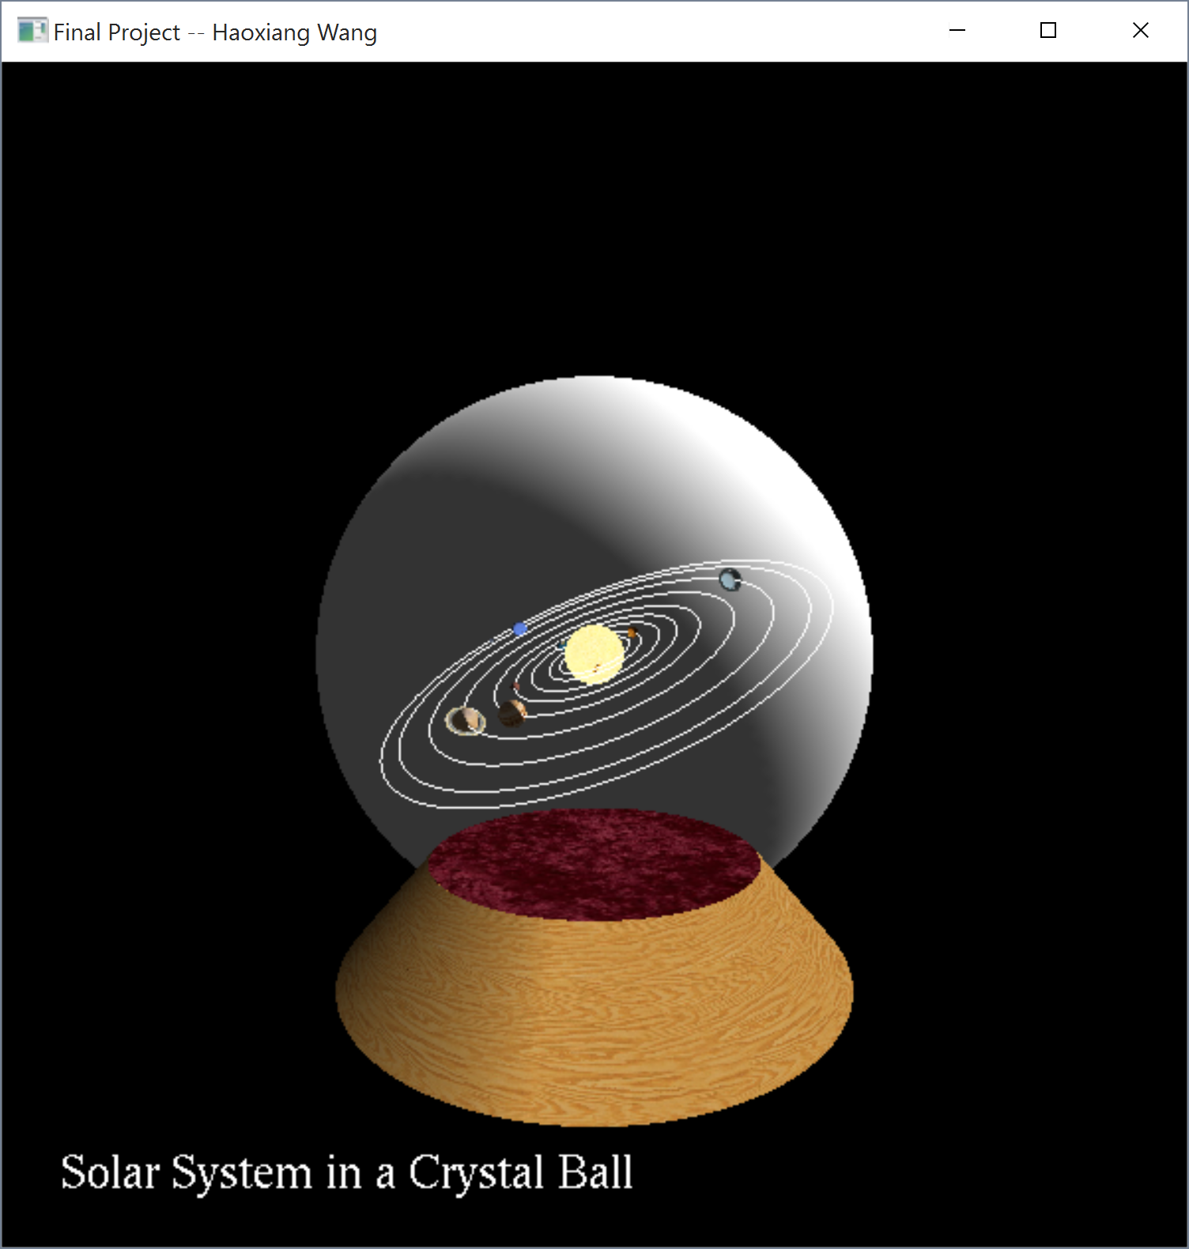 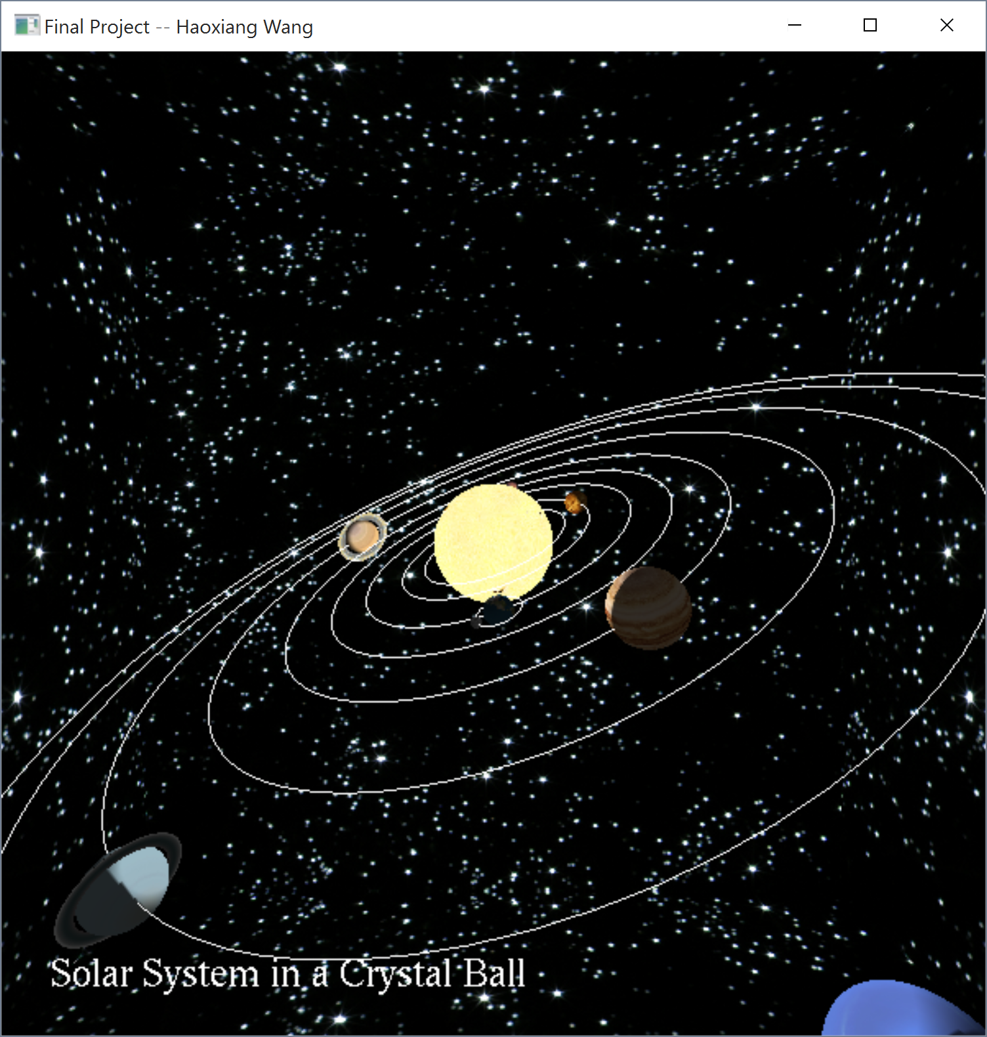

Figure 1. Outside View Figure 2. Inside View

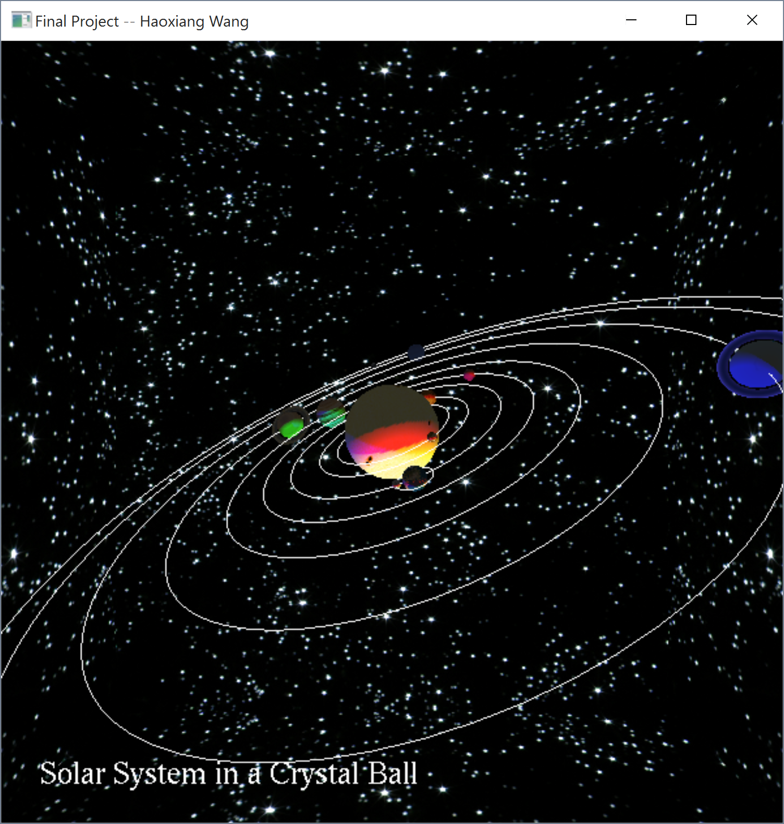 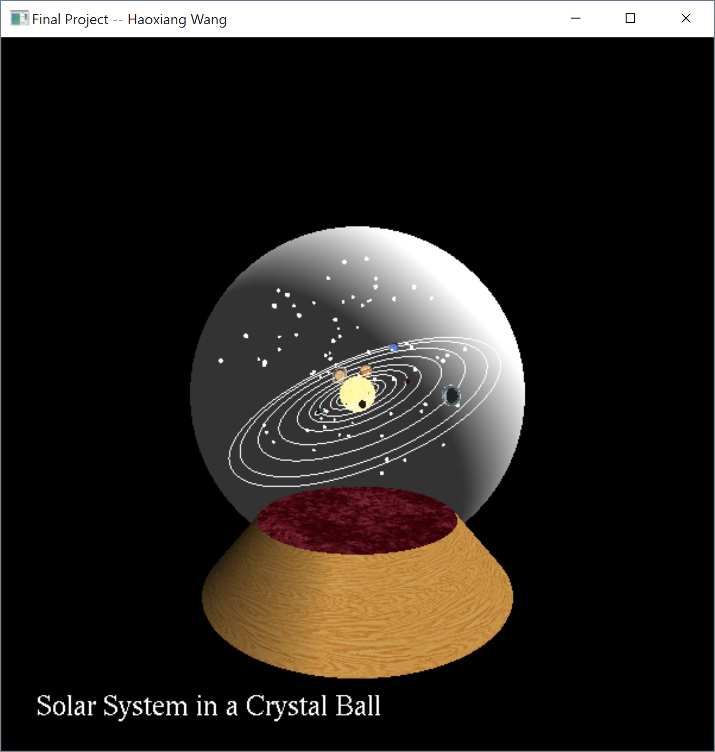

Figure 3. Disco Mode Figure 4. Snow Mode

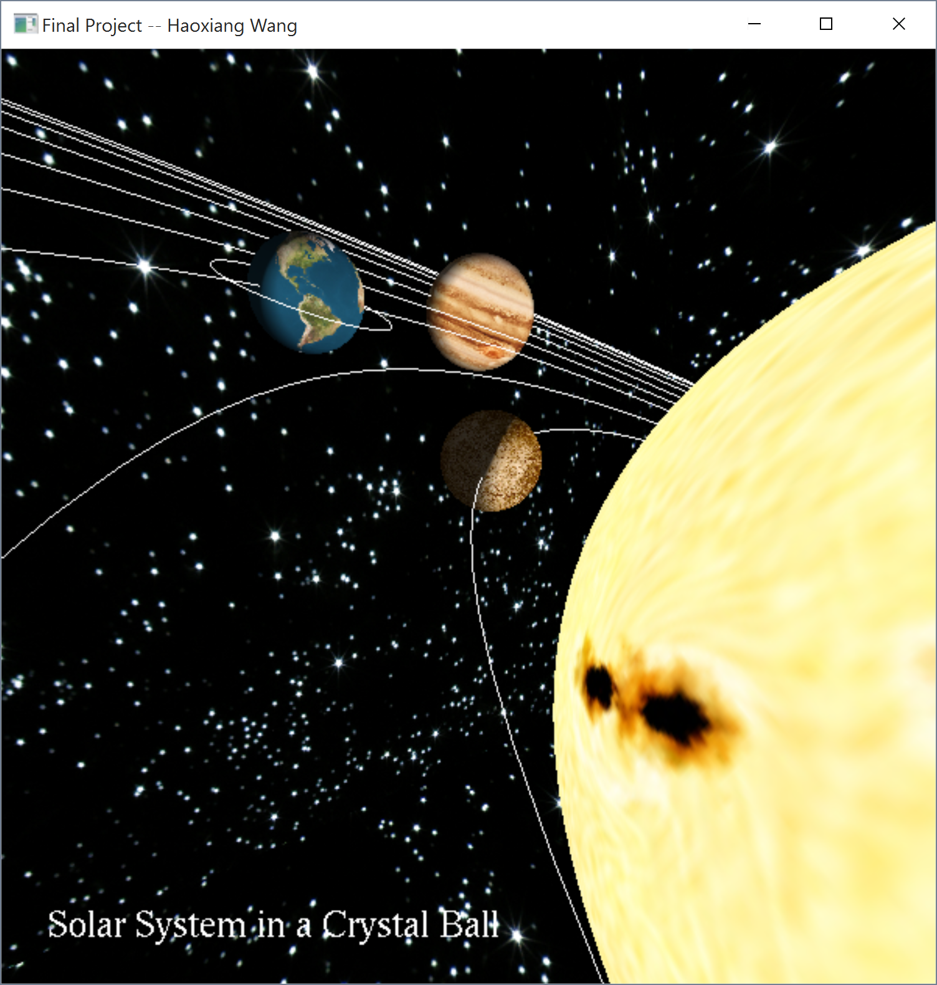 Figure 5. Space Trip